**MEMORANDUM**

**DATE:** May 22, 2020

**TO:** Mayor, Council President and Councilmembers

**FROM:** Tim Johnson

**SUBJECT:** SAVINGS:Are Federal Way Residents Nervous or Frugal Savers?

Sometimes, government statistics look out of order, if not erratic. Economic reports can become irrational as the analysts fail to convey the outcome. Such is the case with this week’s latest report on personal income, spending and savings from the U.S. Department of Commerce, Bureau of Economic Analysis.

Specifically, the report identifies that personal savings was $6.15 trillion in April. The personal saving rate is savings as a percentage of disposable personal income. In other words, it's the percentage of people's incomes left after they pay taxes and spend money. The savings rate reported was an unprecedented 33% in April. In comparison, the highest savings rate in recent years occurred in 2012 where Americans saved 12 percent.

So, is this an anomaly or is something haywire with the data? Did Americans, Washingtonians and Federal Way residents save their stimulus checks? The aggregate number for April far exceeds the total allocation of the stimulus checks from the $2.2 trillion from the CARES Act. So how did this happen?

INSIGHT

Prior to the pandemic, personal savings for Americans was $1.3 trillion or 7.8 percent in the third quarter and $1.29 trillion or 7.7 percent in the fourth quarter of 2019. The range for personal savings since the “Great Recession” has been running 6 to 7 percent annually.

As show in the following chart Americans have done a far better job of saving during this economic expansion (the longest in the nation’s history) than the expansion prior to the Great Recession.

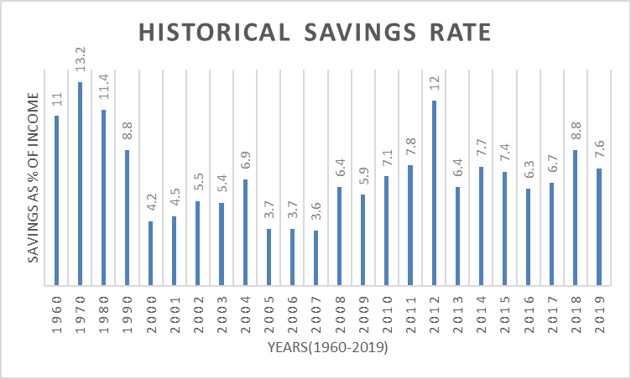

According to the 2016 Federal Reserve’s Survey of Consumer Finances, which is conducted every three years and its latest edition, illustrated that 60 percent of households had set aside enough in savings for at least one month for reoccurring expenses. Meanwhile, the Survey also identified that 40 percent of households had at least 3 months set aside in savings for reoccurring expenses. And nearly 30 percent had enough for 6 months. However, given the above data it illustrates that Americans have been placing more into savings. Again, according to the Federal Reserve’s Survey of Consumer Finances, Americans average household savings balance is $40,200.

So, are Americans, Washingtonians and Federal Way residents better off to weather the downturn created by the pandemic due to their increase in savings?

The following graph from the U.S. Department of Commerce depicts savings rates on a monthly basis from June 2015 through March 2020. Interestingly, there is a light upward trend in January followed by a huge spike in March. So was this a direct consequence from the impact of COVID-19 on consumption or was everyone beginning to save before the economy closed?

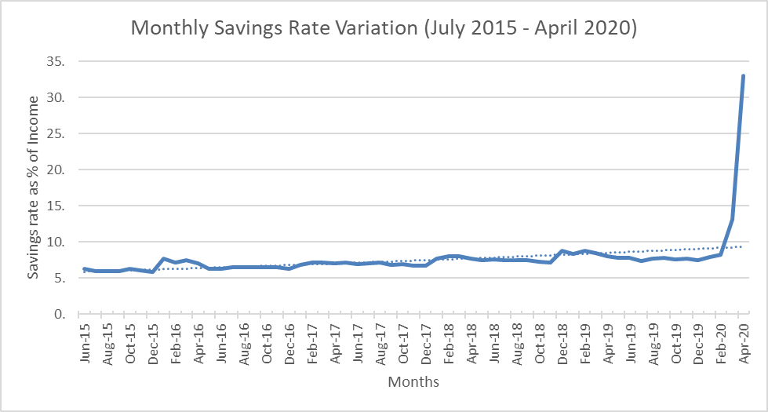

SAVINGS BY AGE/INCOME/ETHNICITY

Income and age are significant elements when examining savings. Individuals approaching retirement age have, not surprisingly, the highest savings rates, specifically individuals with higher income. The following chart details the average savings rate for each income-age combination. Those 60 plus year-old illustrates the group with the highest savings. Studies show that savings rates have recently been so closely correlated with age that, research identifies that 75% of households will be able to maintain their standard of living in retirement.

The reasoning for this is quite intuitive; as individuals approach retirement age, they become more dedicated to ensuring financial stability post-retirement. Moreover, older individuals tend to also have family and personal obligations such as college education of their children and property purchases that incentivize them to save more. Younger individuals face immediate consumption needs such as, student debt and rent or possibly even a mortgage payment. They unfortunately lack available financial resources for savings.

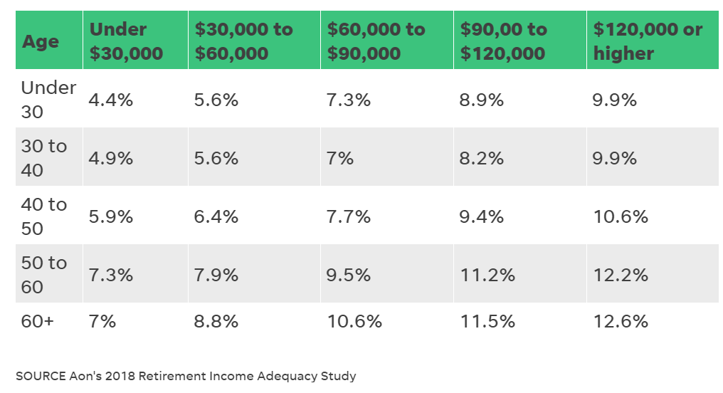

A number of studies have shown a gap that exists between different ethnic populations. Further, research illustrates that the gap persists even with the same income levels. The compendium of research on this subject identifies that there are a variety of explanations to account for the disparities in savings that cannot be explained solely by income. One obvious hypothesis to explain this discrepancy is that there are cultural differences in certain ethnic communities in which the focus is on providing for the extended family thus reducing personal savings rates.

Meanwhile, economic projections show that 75% to 85% of U.S. households are saving adequately for retirement. Importantly, where saving shortfalls occur, they tend to be quite modest. But whether savings serve as a recession cushion depends in part on how they are distributed.

GLOBAL COMPARISON

Compared to other high-income countries, The US has had one of the strongest savings rate growth rates in the world. The following graph compares the historical savings rate across the G-7 countries from 2000-2018. Germany has consistently had the highest savings rates however; the US has also seen strong growth in savings rate during this same period. The remaining countries have had historically low savings rates coupled with occasional downward trajectories. For example, the United Kingdom reported an aggregate savings rate of -0.2% in 2017.

CONCLUSION

In an academic paper entitled “The Origins of Savings Behavior” presented by Professor Henrik Cronqvist, from the University of Washington, he identified the origins of individuals’ savings behavior. In the paper he raises the fundamental question: Where does an individual’s savings behavior originate? What makes one individual a “spender” while another individual, with similar income and similar socioeconomic characteristics, becomes a “saver”?

Economists have emphasized that behaviors and preferences may be socially (as opposed to genetically) transmitted from parents to their children.

Professor Cronqvist identified that casual evidence indeed seems to suggest that some parents give their children a piggy bank, open a savings account, and instill the importance of being frugal, while other parents do not. Such parent-child socialization imply that children adopt their parents’ consumption-savings choices by learning.

Stress does strange things to the human psyche. The COVID-19 has certainly placed the global society in a stressful environment. So, is there a reason for the spike of savings in April? Higher savings can be positive when it represents prudent behavior, for example preparation for retirement. It can also act as a cushion against recession. Rainy-day funds enable consumers—who account for two-thirds of economic output—to continue spending despite a job loss, reduced hours or slashed bonuses.

Professor Cronqvist concludes that individual-specific life experiences are a very important explanation for behavior in the savings domain, and strongest in urban communities. In a world progressing rapidly towards individual retirement savings autonomy, understanding the origins of individuals’ savings behavior are of key importance to economists as well as policy makers.

Meanwhile, recovery from economic downturns is often measured by responses to the GDP. However, the infusion or stimulus of capital by our federal government will not reflect in the GDP until the capital is spent by the beneficiaries (residents of Federal Way) as consumption or investment (savings) because saved capital does not create new demand for goods and services. As a result, the savings rate is a key variable in economic recovery.

So, economists tell us, that as the risk from the coronavirus is lowered, businesses begin to open up and the unemployed return to work, individuals and businesses will tend to consume more creating a system of self-correction for the economy.

Now, as it relates to the nature of the economic data presented related to savings, the Bureau of Economic Analysis provided the following caveat:

The April estimate for personal income and outlays was impacted by the response

to the spread of COVID-19, as federal economic recovery payments were distributed,

and governments continued with “stay-at-home” orders. The full economic effects of

the COVID-19 pandemic cannot be quantified in the personal income and outlays

estimate for April because the impacts are generally embedded in source data and

cannot be separately identified.

It appears the analysts gave up over the complexity of the data. Meanwhile, are Federal Way residents nervous about the future or just frugal? You be the economist.

_____________________________________________________________________________________Assistance was provided to this memo by Soham Ghose, a graduating senior in quantitative economics at the University of Washington. Soham is an economic development intern for the City of Federal Way. Soham was born and raised in Bangalore, India. He is fluent in Hindi, Bengali and English and has basic fluency in Spanish and French. He previously worked for Arab Financial Services in Bahrain.